Please do not include author information on this page!

Abstract
Keywords

- Introduction
Text…

- Methodology
Text…

- Literature review
Text…
  - Subchapter
Text…
Table 1 – This is the title of Table 1
Column 1 | Column 2

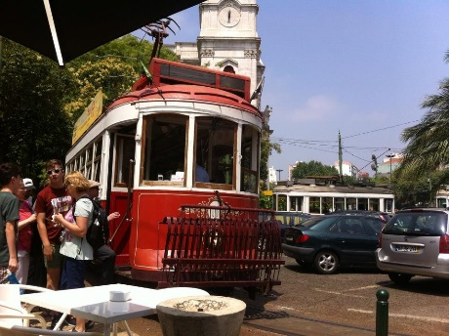
Figure 1 – This is the Title of Figure 1
  - Subchapter
Text…

- Empirical component
Text…

- Discussion
Text…

- Conclusions
Text…
Bibliographical References

You should use adapted APA style as per the following examples, ordering your references alphabetically.

For books:
SURNAME, N. (publication year). Title (edition ed.). Publication Place: Editor.

For book chapter:
SURNAME, N. (publication year). Chapter title. Book Title (edition., pp pages). Publication Place: Editor.

For journal articles:
SURNAME, N. (publication year). Title. Journal Title, volume(number), pages.

For conference articles:
SURNAME, N. (year). Title. Proceedings Title (Vol. volume, p pages). Presented at the Conference Name, Place: Editor.

For reports:
SURNAME, N. (publication year). Report Title (No. report number). Chapter Title (pp pages). Place: Institution.

For Theses:
SURNAME, N. (year). Title (Master’s Thesis / PhD Thesis). University, Place.

For Web pages:
SURNAME, N. (publication year). Title. Web Page Title [Online]. Available at: URL [Accessed on access date].

